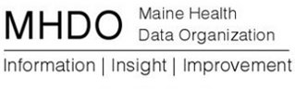

Super Data User Group

Wednesday, December 18, 2013

Muskie, Room 419/427

Portland, ME

1:00 p.m. to 2:30 p.m

Call-in number: 877-455-0244

Conference code: 7281882859

Agenda

* Briefing on NAHDO and APCD  2013 Annual Meeting-5 minutes
* Review/Discuss Data User Feedback Document-40 minutes
* Review/Discuss Road Map-15 minutes
* Review/Discuss Reporting from Current MHDO Data-20 minutes
* Identify key issues for next meeting-10 minutes